# Minutes of Joint Network Meeting

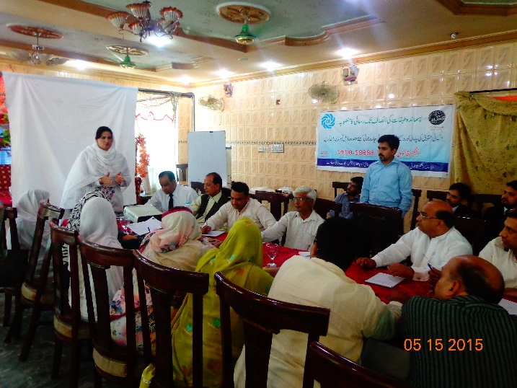

|  |  |  |  |
| --- | --- | --- | --- |
| **S. No** | **Name** | **Designation** | **Department/ORG** |
| 1 | Shazadi Arshad | District Coordinator | SAP- PK |
| 2 | Zakia Rani | G Secretary | Hiyatul Huda |
| 3 | Shaheen Fatima | President | MCH Society |
| 4 | Ghulam Jilani | President | Hiyatul Huda |
| 5 | Sadiq Masih | G Sectary | Youth Welfare Society |
| 6 | Shahid Waseer | DDO (S W) | Social Welfare |
| 7 | Sarfraz Hussian | Director HR | Sanjh Preet |
| 8 | Shahida Rafiq | DLAC Staff | RCDS |
| 9 | Chudary Afzal Haq | President Press Club NNS | AJ TV |
| 10 | Yasmeen | Finance Secretary | Bahali Mazooran |
| 11 | Rana M. Siddique | President | Bahali Mazooran |
| 12 | Hafiza Saima | Finance Secretary | Pahchan Welfare Society |
| 13 | Malik Sajjad Hussain Chatta | Member Bar NNS |  |
| 14 | Tahir Sahib | Area Manager | RCDS |
| 15 | Ali Ahmad | Branch Manager | RCDS |
| 16 | Kashif | M& E | SAP PK |
| 17 | Rane Shamim | President | Koshash Foundation |
| 18 | Abid Ali Abid | President | PECHAN |
| 19 | Gulam Sarwar | Employ | Bahale- Mazoran |
| 20 | Ray Mehmood Ahmad Kharal | President District Bar |  |
| 21 | Ehsan-ul Haq | Employ | Bahale- Mazoran |
| 22 | Zeeshan Ali | Employ | Bahale Mazoran |
| 23 | Gulam Abbas Haidery | Advocate |  |
| 24 | Mudabbar Azam | Advocate |  |
| 25 | Javed | Social Worker |  |
| 26 | Same- Ulla Asmane | Reporter |  |
| 27 | Waqas Janjoa | INP |  |
| 28 | Malik Khurram | INP |  |
| 39 | Yasir Ali | DLAC | RCDS |
| 30 | Farhat Parveen | Center Coordinator | DLAC RCDS |

**Agenda of Joint Network Meeting**

|  |  |  |  |
| --- | --- | --- | --- |
| Agenda of the Meeting | | | |
|  | **Activity** | **Time** | **Responsibility** |
|  | Welcome And Introduction  Participants , Bhali Mazooran | 10:00 to 10:20 | Sadeeq Sahib, President Bahli Mazooran Welfare org |
|  | Progress Update by DLAC | 10:20 to 10:50 | Center Coordinator |
|  | Follow-up on Action Points | 10:50 to 11:20 | All Participants |
|  | Recommendations for Joint Network | 11:20 to 11:50 | All participants |
|  | Formation of ToRs for Joint network | 11:50 to 12:10 | INP/ DLAC |
|  | Action Points for future meetings | 12:10to 12:30 | All Participants |

**Welcome and Introduction**

1. Dastageer Legal Aid Center (DLAC) RCDS in collaboration INP (Islamabad) and Bahali Mazooran Welfare Society (an organization for the PWDs) organized a joint network meeting on 5th May, 2015 at Golden Hall NNS. After the welcome by Ms. Farhat, Center Coordinator, M. Siddique President Bahali Mazooran gave a brief overview about his organization that is formulated for persons with disabilities by persons with disabilities.

**Agenda Item 2, 3 & 4 Progress update and recommendations for Joint Network**

1. The participants showed enthusiasm to be part of Justice Cluster of all rights based organizations of the district. Discussing its importance, M. Tahir, Area Manager, RCDS, Mudabbar Azam (Advocate) Sarfraz Hussain, Director HR, Sanjh Preet and Abid Ali Abid, President PEHCHAN emphasized the importance of such a network at a local level. They all agreed that this will provide a platform to all local NGOs to better facilitate the community in respect of all services and will strengthen the referral mechanism at the local level both with civil societies and the government departments. In addition this forum will also help protect the organizations themselves.
2. Participants discussed there should be representation of all community groups in that network including lawyers, teachers, welfare department, doctors, farmer leaders and labor etc.
3. Some of the participants argued that already all Pakistan Civil Societies forum had already been formed therefore there is no need of creating a new network. Other participants replied that that all organizations cannot become a part of that society network due to specific policy procedures.
4. Sami Ullah news reporter from Sajak local news agency proposed that there is a need to strengthen the existing network of NGOs instead of making new proposed network.
5. The participants suggested the name as “Nankana Sahib Human Rights Development Network (NHRDN) whose basic objectives will be to:
6. Strengthen the referral mechanism
7. Capacity building of local Civil Society Organizations as Paralegals
8. Addressing human rights conflict/ issues in the district

**Action Points:**

|  |  |
| --- | --- |
| **Action Required** | **Responsibility** |
| Finalization of Justice Group Name | DLAC Nankana Sahib |
| Finalization of Charter Of Justice and ToRs | DLAC Nankana Sahib |